CS-540-10148-M01 Data Literacy & Visualization 2026
Module Four Assignment Guidelines and Rubric
Web Page

CS 540 Module Four Assignment Guidelines and Rubric
Overview
This assignment builds your ability to compare different types of visualizations that represent the same data set. The skill of selecting and defending a visualization is essential for professionals who need to present data clearly and effectively to a variety of audiences. Knowing how to choose the best visual format supports accurate interpretation and informed decision making.
In your field of study or workplace, you may be asked to justify why one chart is more effective than another when communicating results to stakeholders, clients, or team members. Practicing this kind of evaluation prepares you to make thoughtful choices that strengthen the impact and credibility of your data presentations.
Scenario
You’ve recently joined a data analytics team at a nonprofit organization that focuses on public policy. Your team is working on a report on regional education funding. Several team members have created different visualizations using the same data set, and leadership wants your input on which one should be featured in the report.
Your audience includes policymakers and education advocates, many of whom are not experts in data analysis. You must evaluate the visualizations and recommend which one communicates the data most effectively to this audience.
Directions
In this assignment, you will write a short analysis comparing multiple data visualizations that represent the same data set. Before you begin, review the data set and the three different visualizations located in the Module Four Assignment data folder in Codio. When you are ready to begin your work, access Codio by clicking the title of the next task.
Specifically, you must address the following rubric criteria:
- Describe how each visualization represents the data.
- Describe the key characteristics of each visualization. Include the following:
  - Chart type
  - Layout
  - Labeling
- Compare the visualizations by analyzing how effectively each one communicates the data set’s insights. Include the following:
  - Clarity
  - Data type alignment
- Evaluate which visualization is most appropriate for the given audience. Include the following:
  - Rationale for your selection
- Recommend multiple refinements to any of the visualizations provided. Include the following:
  - Justification of how the refinements would better suit the audience’s needs
What to Submit
Submit your assignment as a 2- to 3-page Microsoft Word document with double spacing, 12-point Times New Roman font, and one-inch margins.
AI Usage
If you use gen AI tools to support your work on this assignment, be sure to follow these AI usage guidelines. You must acknowledge your use of these tools in your work. Guidelines on how to cite AI tools can be found in this Shapiro Library guide.
4-3 Assignment: Comparing Visualizations for Impact
Codio:
https://codio.com/kjoshi131918118/4-3-assignment--comparing-visualizations-for-impact
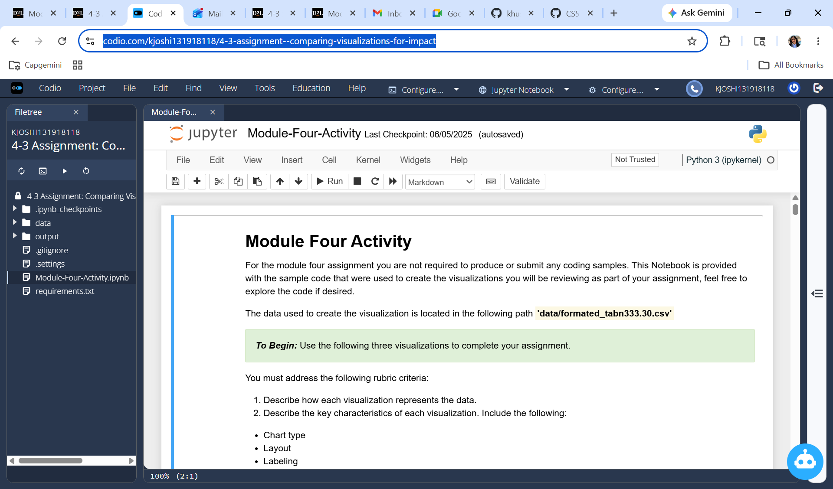
UID: khushbu.joshi@snhu.edu
PWD:-Bapa@1982

